Additional information to answer question 6.3 of the SCR exercise

For example, we want to calculate the NO_{x} conversion at 10 ppm slip at 450 °C:

- Locate the corresponding NH_{3,in} concentrations where the NH_{3,out} values are below and above 10 ppm. In this case, they are 500 and 550 ppm NH_{3,in}
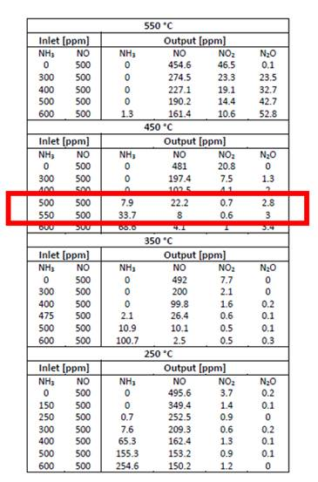
- Calculate the NO_{x} conversions at these two points.
- Use the linear interpolation formula to calculate the NO_{x} conversion at 10 ppm slip.
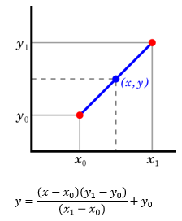

where y is the NO_{x} conversion at 10 ppm slip
x is 10 ppm
x₀ is 7.9 ppm
x₁ is 33.7 ppm
y₀ is the NO_{x} conversion at 7.9 ppm NH₃ slip
y₁ is the NO_{x} conversion at 33.7 ppm NH₃ slip

